CSC/ITE220 Web Development II
Final Group Project Report
Course Registration System
Group Number: 4

Group Members: 4
Sai Lin Phyo | 2409180001 | Team Lead / Integrator + Frontend B
Min Khit Oo | 2409120002 | Database & Data Lead
Lin Htet | 2410010002 | Backend / API Developer
Snezhana Ochkurova | 231113014 | Frontend A: Admin & Advisor

- Project Overview
CourseReg is a full stack university Course Registration System developed using MongoDB, Express, React and Node.js. The purpose of the project is to create a working course registration system for three types of users: Administrator, Advisor and Student. Each user has a different dashboard and different permissions. The Administrator manages user accounts. The Advisor manages course offerings and student registrations. Students can view their current courses, academic record, GPA, credits, failed courses and Add/Drop information. The frontend was developed using React and Vite, while the backend uses Node.js and Express. MongoDB Atlas is used as the database with Mongoose models and validation. Authentication is handled using bcrypt password hashing and JSON Web Tokens. The system was designed so that the frontend, backend and database are separated clearly. React is responsible for the user interface, Express routes and controllers manage requests and business logic and MongoDB stores the application data.

- Database and System Design
The system uses six main MongoDB models: User, Course, Offering, Registration, Record and Notification. User stores Admin, Advisor and Student accounts. Course stores permanent course information, while Offering stores term specific section details such as instructor, schedule, room, seats and Add/Drop settings. Registration stores current term enrolments, Record stores previous academic results, and Notification stores registration related messages.
Relationships are implemented using MongoDB ObjectIds and Mongoose references. Mongoose validation is used for required fields, role and grade values, unique fields and default values. The seed script creates 25 students, 4 advisors, 1 administrator, 18 courses, 26 current term sections and 312 completed course records, including F, W, full section, already passed and time clash test cases.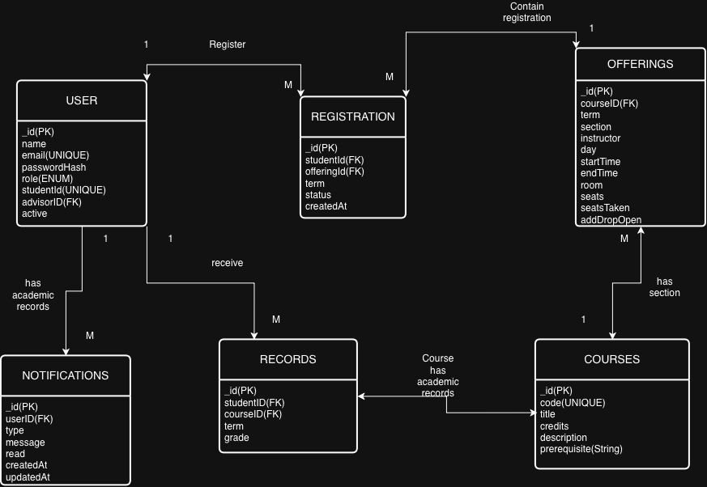

- Authentication and Security
The application uses one login page for all three roles. Passwords are stored as bcrypt hashes, while JWT is used to authenticate protected API requests. Authentication and role middleware ensure that users can only access routes allowed for their role. Sensitive values such as the MongoDB connection string and JWT secret are stored in .env, which is excluded from GitHub together with node_modules. An .env.example file is provided without real secret values.

- Registration Rules Engine
The registration rules engine is one of the main parts of the project. When an Advisor selects a Student, the system checks the Student’s academic record, current registrations and the course offerings available for the current term. The first rule checks whether the course is offered during the selected term. If the course has no current offering, it cannot be selected. The second rule checks whether the Student has already passed the course. Grades A, B+, B, C+, C, D+ and D are considered passing grades. If the Student has already passed the course the course cannot be registered again. If the Student previously received an F, the course is marked as Retake Required and should be prioritized in the eligible course list. A W grade is treated as a withdrawal, so the Student is allowed to take the course again. The system also checks seat availability. If a section has no remaining seats, it is shown as Full and cannot be selected. Time conflicts are also checked. If the selected section overlaps another registered or selected course on the same day, the section is blocked and the conflicting course is identified. The project also supports prerequisite checking as an additional rule. Instead of hiding excluded courses, the system shows a reason such as: Already passed – grade B, Full – 0 seats remaining, Clashes with another registered course, Prerequisite does not meet and already registered this term. This makes the eligibility decision easier for the Advisor to understand.

- Role Based Features
5.1 Administrator
The Administrator manages user accounts through the Admin Dashboard. Admins can view and search users, filter by role, create accounts, edit information and deactivate or reactivate users. Changes are stored in MongoDB.
5.2 Advisor
The Advisor manages course offerings and student registrations. Advisors can create, edit and remove offerings, view seat information, select students, view academic records and register eligible courses using the rules engine. Advisors also control the Add/Drop status and closing date of course offerings, and registration changes can create Student notifications.
5.3 Student
Students can view their current courses, academic record, GPA, credits, progress and failed courses marked Retake Required. They can browse current offerings but cannot register themselves. The Add/Drop page shows course status and provides the request form, instructions and Advisor contact information when Add/Drop is open.

- Testing and Results
Testing was performed at the database, API and frontend levels. Database tests checked the six Mongoose models, validation rules and seed data. The seed verification confirmed 25 Students, 4 Advisors, 1 Admin, 18 Courses, 26 sections and 312 academic records, including F, W, full section, already passed and timetable clash cases.
API testing covered authentication, protected routes, Student records, eligibility, offerings and registration operations. Responses included appropriate status codes such as 200, 401, 403, 404 and 409. Frontend testing used Admin, Advisor and Student accounts to confirm that application changes were stored in MongoDB and remained after refreshing.
- Problems Faced and Solutions
The main challenge was keeping the frontend, backend and database consistent while team members worked on separate Git branches. Changes to shared fields and API responses sometimes affected multiple parts of the system. The team solved this by communicating changes, testing affected pages and endpoints, and using integration branches before merging into main.
Other issues included React/Vite configuration errors, invalid JWT tokens, missing npm packages and outdated local branches. These were solved by correcting imports and filenames, using fresh login tokens, running npm install, working from clean repository copies and merging the latest main branch before final integration.

- Division of Work
Sai Lin Phyo – Team Lead/Integrator + Frontend B
Developed the Student frontend, including Login, Dashboard, My Courses, Academic Record, Browse Courses, Add/Drop, shared components and notification integration. As Team Lead, managed Git branches, integration testing and merges, and coordinated frontend, backend and database changes.

Min Khit Oo – Database & Data Lead
Designed and maintained the Mongoose models, relationships, seed data and database verification tests. He also verified required dataset counts and registration rule scenarios such as F, W, full section, already passed and time clash cases.

Lin Htet – Backend/API Developer
Developed Express routes, controllers, authentication and authorization middleware, registration APIs and rules engine integration. He also tested protected endpoints, authentication, course data, student records and registration operations.

Snezhana Ochkurova – Frontend A: Admin and Advisor
Developed the Admin and Advisor interfaces, including User Management, Manage Offerings, Student Registration and Add/Drop Management, and connected Advisor actions to Student notifications.

- AI Assistance
AI was used to explain React, Express, Mongoose and Git concepts, assist debugging and help prepare testing procedures. Suggestions were reviewed against the project requirements and tested locally using MongoDB Atlas, the backend API and frontend application. The team modified or rejected AI suggestions when they did not produce the required behavior.

- Conclusion
The project combines MongoDB, Express, React and Node.js into a complete role based Course Registration System. It provides Admin, Advisor and Student workflows, secure authentication and a registration rules engine that checks academic history, seat availability and timetable conflicts. The project provided practical experience in database design, API development, frontend/backend integration, testing and Git collaboration.

